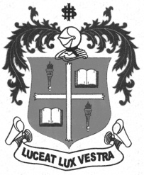
LOYOLA COLLEGE (AUTONOMOUS), CHENNAI – 600 034
M.A. DEGREE EXAMINATION - APPLIED HISTORY
SECOND SEMESTER – APRIL 2012

HT 2954/1813 - INTELLECTUAL HISTORY OF INDIA

Date : 26-04-2012 Dept. No. Max. : 100 Marks

Time : 9:00 - 12:00

PART – A

Answer any Four of the following in about 100 words each: (4 x 5 = 20 Marks)
- Modernism
- Dravida Kazhagam
- Total Revolution
- Servants of India Society
- Aligarh Movement
- Define Socialism

PART – B

Answer any Two of the following in about 200 words: (2 x 10 = 20 Marks)
- Write a brief note on social ideas of Rajaram Mohan Roy.
- Examine the objectives and activities of SNDP.
- Point out the significant ideas of Tagore on Nationalism.
- Give an account of Nehru’s attitude towards communism.

PART – C

Answer any Three of the following in about 1200 words: (3 x 20 = 60 Marks)
- Analyse the political and economic condition of India in 19th century India.
- Describe the contributions of E.V. Ramasamy Naicker to Tamil Society.
- Examine the Political Thought of Jaya Prakash Naryan.
- Discuss the socio-economic and political philosophy of Gandhiji.
- Assess the contributions of Dr. B.R. Ambedhkar to the Indian constitution.

************

